Image zoom
- This article applies to versions:
- CS-Cart (Full)
Is everything clear and correct? Click to report an insufficient or poor description

This add-on adds the possibility for customers to zoom product images by hovering a mouse pointer over the picture.
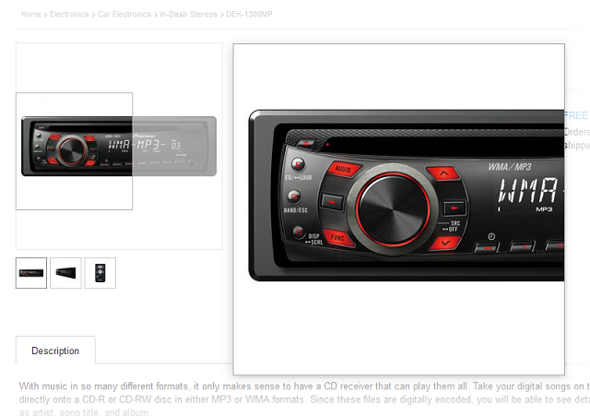

• | Opacity - Opacity of tint for the product picture. Define any value between 0 and 1. If 0, no tint will be visible.
• | Animation time - Duration of the animation effects in milliseconds. The more the value, the slower the zoom picture appears on the screen.

• | Color - Color to use for the tint effect.
Important: Color must be defined as hexadecimal HTML color from #000000 for black to #FFFFFF for white.
• | Zoom position - Specifies position of zoom window. Numeric (0-15) positions are relative to page image as shown by the following key (blue squares represent zoom window:)
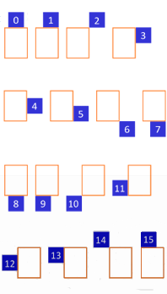
• | Zoom size mode - Defines the rule for sizing the zoom window and lens: Image - Zoom window will match small image; Lens - CSS of lens (.cloudzoom-lens) has priority, zoom window will be adjusted; Zoom - CSS of zoom window (.cloudzoom-zoom) has priority, lens will be adjusted; Full - Zoom window will maximise to full size of zoom image.
• | Caption position - Position of the image caption: Top or Bottom.

• | Ease time - Number of milliseconds of mouse easing movement of zoom image. The bigger the number, the more easing. Zero means no easing.
• | Zoom fly out - If selected, the flying zoom animation is enabled.

